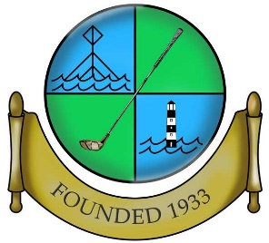

HOYLAKE GOLF CLUB

Application Form
Affiliated to the Cheshire Union of Golf Clubs & The English Golf Union.

Applicants Name: Age:

Address:
Post Code:
Phone No: E-Mail:

Please Return to Mr Dave Denton, Club Secretary, Hoylake Golf Club, Carr Lane, Hoylake, CH47 4HB.

Are you, or have you ever been a member of another Golf Club?
Golf Club. From To

Golf Club. From To

Current, or if not current, previously attained lowest handicap
If you intend to remain a member of another golf club, is responsibility for your handicap to be transferred to Hoylake Golf Club? Yes / No (Delete as necessary).

If you intend to transfer your handicap to Hoylake GC please obtain a current handicap certificate.

If you are not a member of another EGU affiliated golf club, Hoylake GC will assess you and award a handicap.

Declaration:
(To be completed by the Proposer & Seconder)
We, the below named, having been members of Hoylake Golf Club for more than 3 years, believe the above named candidate to be a suitable person to be elected as a member of the Hoylake Golf Club.

Proposed by: Signature:

Seconded by: Signature:

It is preferred, but not essential to have a proposer and seconder. Each application will be considered on its own merits.

Signature of Applicant: Date:

